4. SQL Exercise - Stored procedure

Exercise 1: Create a Stored Procedure

Step 1: Create Database
CREATE DATABASE EmployeeDB;

Step 2: Use Database
USE EmployeeDB;

Step 3: Create Employees Table
CREATE TABLE Employees (
EmployeeID INT AUTO_INCREMENT PRIMARY KEY,
FirstName VARCHAR(50),
LastName VARCHAR(50),
DepartmentID INT,
Salary DECIMAL(10,2),
JoinDate DATE
);

Step 4: Insert Sample Records
INSERT INTO Employees
(FirstName, LastName, DepartmentID, Salary, JoinDate)
VALUES
('John','Smith',1,50000,'2023-01-15'),
('Alice','Johnson',2,60000,'2022-08-20'),
('Robert','Brown',1,55000,'2021-06-10'),
('Emma','Wilson',3,70000,'2024-02-05'),
('David','Miller',2,65000,'2023-11-18');

Step 5: View the Table
SELECT * FROM Employees;

Output:
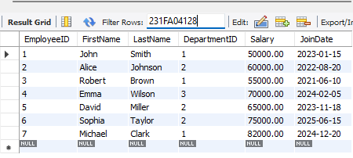
Step 6: Create Stored Procedure to Retrieve Employees by Department
DELIMITER //
CREATE PROCEDURE sp_GetEmployeesByDepartment(
IN p_DepartmentID INT
)
BEGIN
SELECT *
FROM Employees
WHERE DepartmentID = p_DepartmentID;
END //
DELIMITER ;

Step 7: Call the Procedure
CALL sp_GetEmployeesByDepartment(1);
CALL sp_GetEmployeesByDepartment(2);
CALL sp_GetEmployeesByDepartment(3);

Step 8: Create Stored Procedure to Insert Employee
DELIMITER //
CREATE PROCEDURE sp_InsertEmployee(
IN p_FirstName VARCHAR(50),
IN p_LastName VARCHAR(50),
IN p_DepartmentID INT,
IN p_Salary DECIMAL(10,2),
IN p_JoinDate DATE
)
BEGIN
INSERT INTO Employees
(
FirstName,
LastName,
DepartmentID,
Salary,
JoinDate
)
VALUES
(
p_FirstName,
p_LastName,
p_DepartmentID,
p_Salary,
p_JoinDate
);
END //
DELIMITER ;
Output:
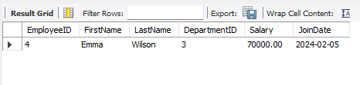
Step 9: Execute the Insert Procedure
CALL sp_InsertEmployee(
'Sophia',
'Taylor',
2,
75000,
'2025-06-15'
);
SELECT * FROM Employees;
Output:
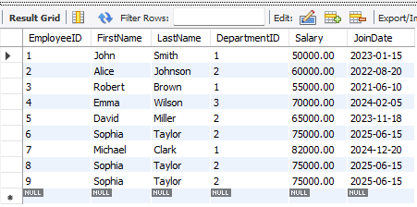
Step 11: Insert Another Employee
CALL sp_InsertEmployee(
'Michael',
'Clark',
1,
82000,
'2024-12-20'
);
SELECT * FROM Employees;
Output:
